Library System Management Requirements

- As a library administrator, I want to be able to add new books to my catalogue.
- As a library administrator, I want to be able to remove books from my catalogue.
- As a library administrator, I want to be able to find a book by title or ISBN.
- As a library administrator, I want to able to log in into the program with a given username and password.
- As a library administrator, I want to able to manage requests from members.
- As a library administrator, I want to be able to manage the content of my catalogue (CRUD).

- As a student, I want to be able to search a book, borrow a book, return it or renew a loan. Personal account management.

Flow Chart

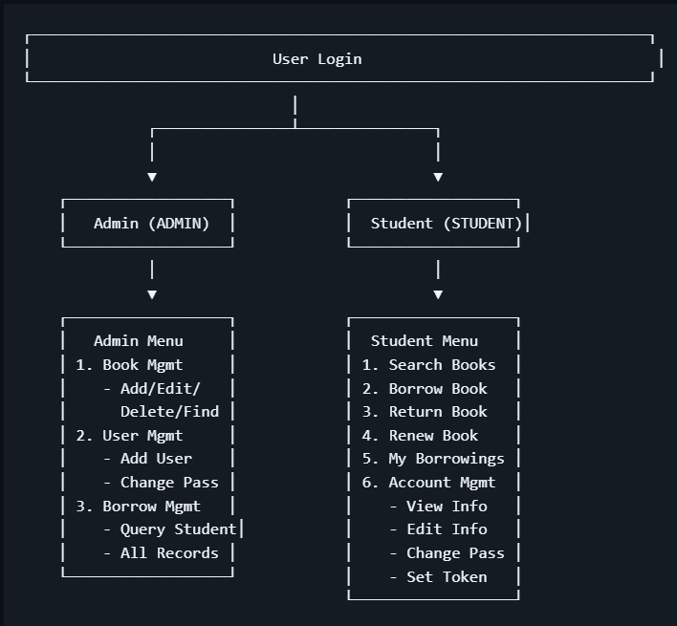

Core Functions1
Book Management (Admin)
Add Book
- Add new book with ISBN, title, author, publisher, category, quantity.
Edit Book
- Modify book information by ISBN
Delete Book
- Remove a book (requires no active borrowings)
Search book
- Search by keyword (title/author/ISBN)
List all Books
- Display all books, sortable by title/author/ISBN
Borrowing Management (Student)
Borrow Book
- Enter ISBN, 8 days of borrowing allowed.
Return Book
- Return borrowed book by record ID.
Renew loan
- Extend borrowing period (Only one week more allowed).
View Borrowings
- View personal borrowing records.

Account Security
Change Password
- Admin can change any user’s password; students can only their own.
Security Token
- Set password recovery token for verification
Forgot Password
- Reset password using username and security token

- Automatic detection of overdue books
- Students are notified of overdue books upon login
- Admin can view all borrowing records with overdue status

